Chapter 7, Solution 88.

As a differentiator,
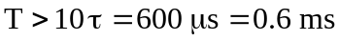
i.e. 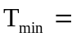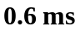
- 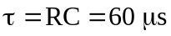
As an integrator,
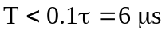
i.e. 